VERSHA NEGI
Mb: 0- 9971832125
versha31@yahoo.com
Objective

Want to be a part of an educational institute working to bring out innovative changes in the field of education.

Personal details 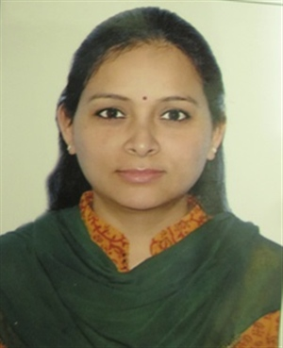

Date of Birth: 17th July, 1982
Husband’s Name: Mr. Abhay Negi
Languages known: English & Hindi

Address for correspondence: House No: 2421, Ground Floor,
Sector-23, Gurugram

Educational Qualification:

Course | Name of the institution | Year of Graduation
B.El.Ed. | Jesus & Mary College,  University of Delhi | 2003
M.Ed. | Central Institute of Education(CIE),  University of Delhi | 2009
M.A. (Linguistics) | Department of Linguistics,  University of Delhi | 2011
M. Phil. (Educational Planning and Administration) | National University of Educational Planning and Administration (NUEPA), New Delhi | 2016

- Qualified UGC-NET DEC 2012 in Linguistics

- Qualified UGC-NET (JRF) JUN 2013 in Education

Teaching Experience:

S.No | Designation | Name of the Institution | From | To
1 | Assistant Professor | Cluster Innovation Centre (CIC), Delhi University | August 2013 | July 2014
2 | Assistant Professor | AIE, Amity University, NOIDA | August 2011 | August 2013
3 | PRT | Delhi International School, Dwarka, Delhi  Maxfort School, Dwarka, Delhi  DSB International public School, Dehradun | April, 2004 | March, 2008

